A Peek Into Fiction with Tunnel Books
Subject: Language Arts
Grade Level: 6
Lesson Plan: Three 50-minute classes

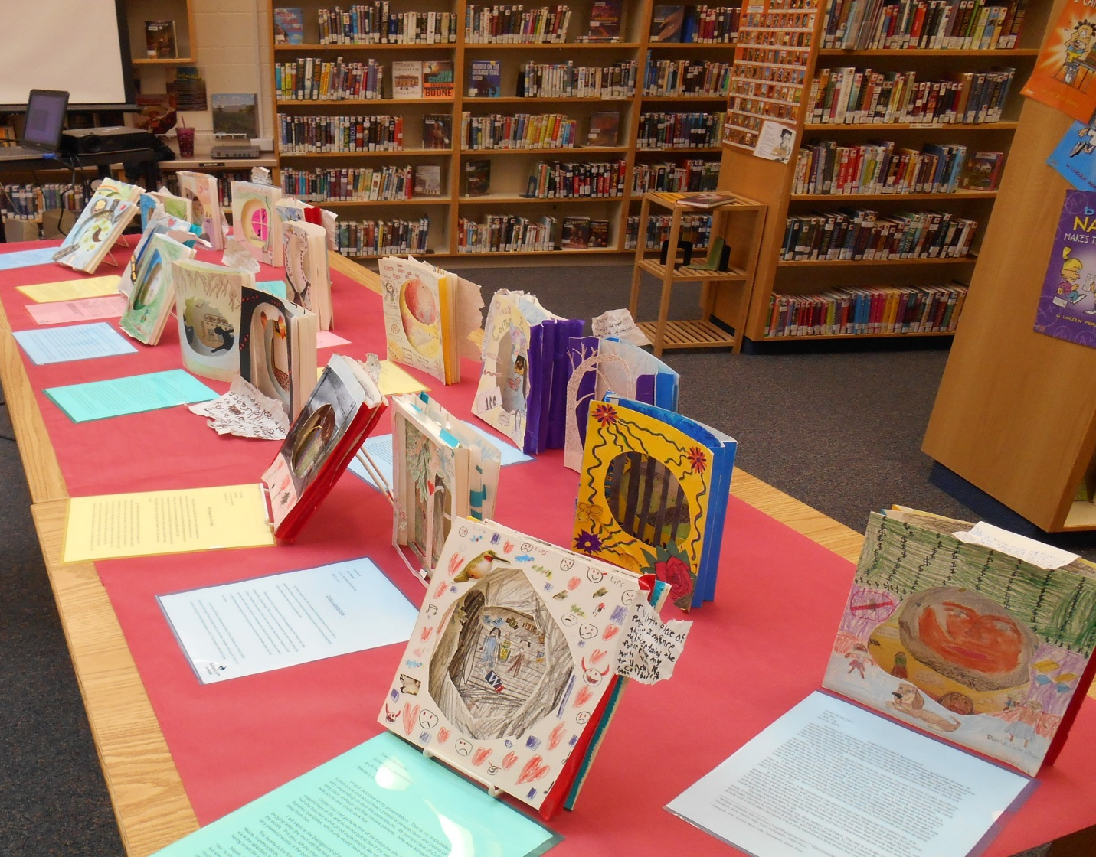

Students will explore the layers and imagery of a character or theme. These tunnel books have three layers, which can be customized to meet the needs of the students. Students are challenged to visually represent the topic through illustration on the tunnel book pages. Students end the project with an artist statement that asks them to reflect on the class subject and the creative process.

Objectives:
- Students will create a tunnel book
- Students will explore various layers of a character or theme
- Students will write an artist statement

Basic Lesson Outline:
- Introduce project
- Demonstrate skills
- Create tunnel books
- Write an artist statement
- Create an art walk / display of tunnel books

Art Supplies:
- White cardstock (at least 7 sheets per student)
- Glue sticks
- Scissors
- Colored pens and pencils

Other Resources:
- Slide show to introduce project and related artwork (see outline at the end of the lesson plan)
- Examples of tunnel books

Idaho State Learning Standards:
- Arts and Humanities: Anchor Standard 4: Convey meaning through the presentation/performance/production of an original work or unique interpretation of a work
  - Objective PR1.1 Combine knowledge and understanding from two or more disciplines to present/perform their original or interpreted works for an audience
  - Objective PR1.2 Convey meaning through their presentation/performance

- RL.6.2 Determine a theme or central idea of a text and how it is conveyed through particular details; provide a summary of the text distinct from personal opinions or judgments

Academic Language:
- Subject area language: theme, character, point of view, narrator
- Art language: tunnel book, perspective, background, middle ground, foreground

Student Use of Vocabulary:
Students will use the words when creating their projects and in their artist statements

Student Grouping:
Students will work individually

Instruction:
Day 1 – Introduction
- Introduce the project with a slide show
  - Questions the teacher can ask: What do you see here? How do you think the artist created this? Why do you think the artist created this piece?
- Demonstrate how a tunnel book is created
  - Show the accordion fold and how the pages are glued to the accordion fold
- Students will sketch ideas for their tunnel books

Day 2 – Artmaking
- Students will create their tunnel books, following the directions and any additional criteria added by the teacher to support project learning goals

Day 3 – Artmaking
- Students will finish their tunnel books
- Students will write an artist statement.
  - The artist statement should contain information about the student’s design choices, the art terms and the subject area terms (see attached artist statement guidelines)
- Students print their artist statements and display them with their tunnel books

Additional Resources:
Instructional video at svmoa.org

Slide Show Outline:
- Examples of tunnel books
- Examples of vocabulary terms to be taught during the lesson
- Examples of art terms to be taught
- Short description of tunnel book directions

Tunnel Book Directions:
    - Create a plan for your tunnel book. Sketch ideas. What will each page show? How many pages will the book have?
    - Accordion fold two pieces of paper. The accordion pages should match. Depending on how the student glues the pages, each accordion valley will hold a page.
    - Draw the background first. Fold about half an inch back on each side. Glue the folded sides to the last fold of each accordion page.
    - Create additional pages, gently folding the paper to cut out a middle section. The middle sections will create the tunnel effect that the viewer will see when they look at the tunnel book. Glue these pages to the accordion folds, starting in the back, working towards the front of the tunnel book.

Funding for this lesson plan was made possible in part by the Institute of Museum and Library Services [MA-10-19-0563-19].
Additional funding provided by Wendy and Alan Pesky.

