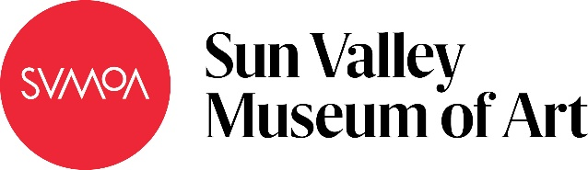

The Animal In Me
Subject: Social Studies
Grade Level: 6
Lesson Plan: Six 50-minute classes

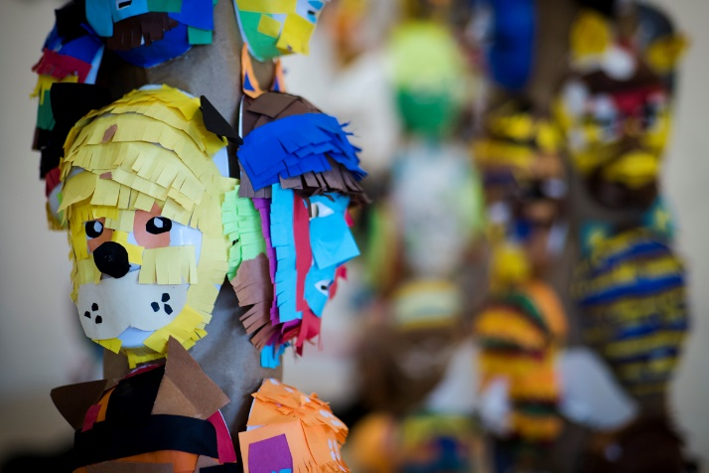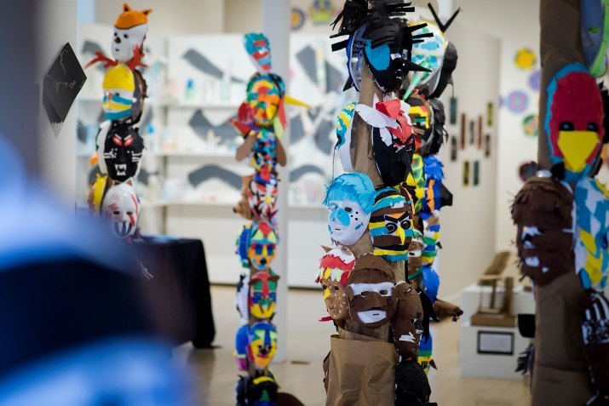

Students will make a personal connection to an aspect of Native American culture, totem poles, and totem animals by researching how native cultures incorporate animals into their art and culture in a variety of ways and creating an individual mask representing personal character traits. Students will then choose an animal based on strengths they identify within themselves.

Objectives:
- Students will identify an animal that they identify with based on their personal character traits
- Students will use texture, color, shape, and form in their animal mask
- Students will reference Native American use of symbolism, color, and shape in creating their mask
- Students will write and present a brief monologue to build confidence through public presentation

Basic Lesson Outline:
- Project introduction (slide show)
- Students will identify character traits and an animal
- Students will be shown examples of how to create form in their masks
- Students will work on their mask
- Students will work to complete their masks; if time allows, they will work on their monologues
- Project conclusion and presentation

Art Supplies:
- Plastic mask forms
- Construction paper
- Glue
- Tacky glue
- Paint brushes
- Photographs of animals (calendars are a great resource)

Other Resources:
- Examples of mask-making techniques
- Slide show to introduce project and related artwork (see outline at the end of the lesson plan)

Idaho State Learning Standards:
- Arts and Humanities: Anchor Standard 4: Convey meaning through the presentation/performance/production of an original work or unique interpretation of a work
  - Objective PR1.1 Combine knowledge and understanding from two or more disciplines to present/perform their original or interpreted works for an audience
  - Objective PR1.2 Convey meaning through their presentation/performance

- 6-9.GWH.5.1.1 Discuss how social institutions, including family, religion, and education, influence behavior in different societies in the Western Hemisphere

Academic Language:
- Subject area language: totem pole, Native American, spirit animal, ritual, and representation
- Art language: form, color, texture, shape, line, symbolism, balance, line, adaptation, and innovation

Student Use of Vocabulary:
Students will use the words when creating their projects, when writing about their projects, and creating and presenting their monologues

Student Grouping:
Students will work independently

Instruction:
Day 1 – Introduction
- Introduce the slide show
- The slide show should be interactive, prompting questions and discussions
- Some of the questions the teacher can ask are:
- What do you see?
- Why do you think the artists did that?
- How do you think the artist did that?
- Introduce the project, going over the project goals with the class
- If time remains, students can begin researching and brainstorming

Day 2 – Artmaking
- Students will use resources provided and research an animal that corresponds to individual character traits
- Provide examples of character traits or personal strengths
- Students should list their own strengths and find animals that symbolically correspond
- Students brainstorm ideas for their mask

Day 3 – Artmaking
- Demonstrate different techniques they can use to decorate and form their masks
- Students will be given the remainder of class to work on their spirit animals
- Encourage them to consider traditional uses of color, shape, and line
- Encourage them to be mindful of form and texture as well

Day 4 – Artmaking
- Remind students of artistic considerations, including texture, shape, balance, color, and form
- Students may also want to think about their strengths and how they can use color and form to communicate them in their design
- Students will spend class working on their masks

Day 5 – Artmaking
- The students will work on and complete their masks
- If they finish their masks, they will use their time to write and prepare their monologues

Day 6 – Presentations
- Students should take turns presenting their work to the class
- In their presentations students should talk about
- The animal they chose
- What traits the animal poses
- How those traits relate to themselves

Additional Resources:
Instructional video at svmoa.org

Slide Show Outline:
Slide Examples:
- Our goal for this project is to facilitate the opportunity for students to identify their strengths and explore them through the metaphor of an animal. Additionally, teachers may want to implement a cultural element to promote cross-cultural exploration and connection.
- We incorporated a cultural element by connecting the project to Native American tribes in Northwestern Canada.
  - We used the second slide to show examples of how the different tribes used different artistic elements in their mask and totem making.
- Techniques and Colors usage: we focused on techniques of form and color in how they functioned to communicate certain symbolic and cultural meanings through the masks.
  - We went through different colors and their symbolic meanings.
  - We also showed how different stylistic techniques are used.
  - We showed how these differed from tribe to tribe.
  - We also noted that students could connect their own personal meanings to colors.
- A sequence of different examples of animal masks were then shown and students were asked to identify colors, techniques, and textures used.
- Uses of Masks: go over how masks were used and their purpose within a cultural framework.
- Choosing your spirit animal: Provide questions to encourage students in their consideration and identification of strengths.
  - What are my strengths?
  - What are some words that describe me?
  - What do I like to do? What do I do a lot? What character traits do I poses?
  - Have you ever been drawn to a particular animal or creature?
  - Does a certain animal appear a lot in your life?
  - Have you ever had a recurring dream in which a specific animal often appears?
- Thinking about Strengths: students will get out a blank piece of paper and record their strengths, things that are important to them, and describe their personality.
We chose to put our masks together in a totem pole-the next slide refer to that.
- Creating a totem pole: Go over the why, who, and how.
We asked students to present a monologue.
- The monologue and presentation: go over what a monologue is and what the expectations are for presenting.
- Reiterate Goals
- Resources: Provide access to examples or artwork and ideas.

End of project Monologue:
- Introduce your spirit animal
- Tell us which tribe or region it comes from in Canada
- Explain what traits it represents and how these relate to you

Funding for this lesson plan was made possible in part by the Institute of Museum and Library Services [MA-10-19-0563-19].
Additional funding provided by Wendy and Alan Pesky.
