Re-Envisioning Our Environment: A Photo Project

SUBJECT: U.S. History
GRADE LEVEL: High School
LESSON PLAN: Five 70-minute classes each

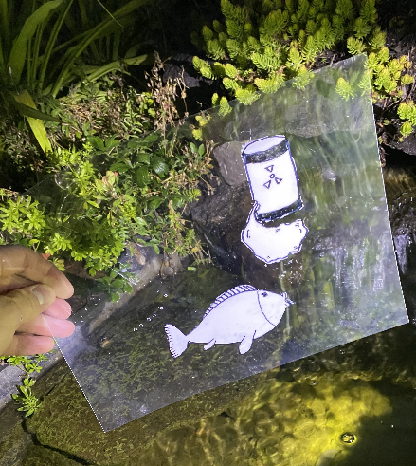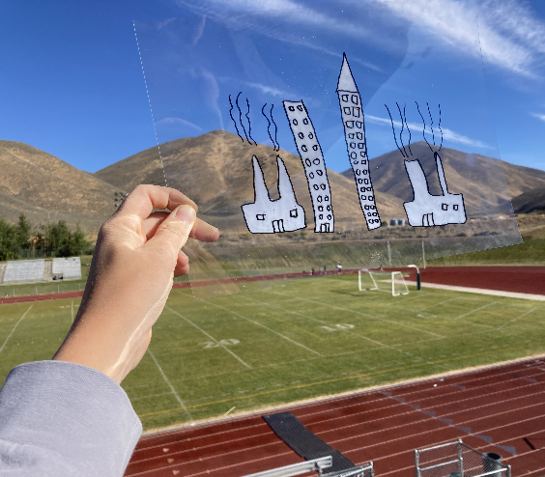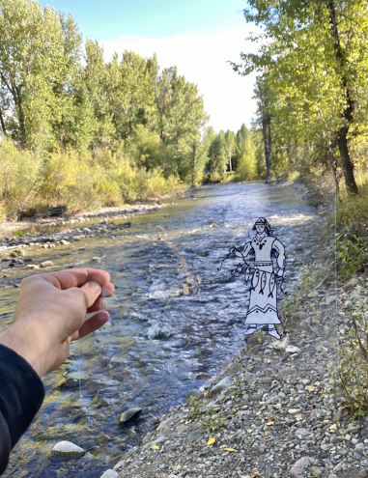

The AP US History students at Wood River High School will be creating digital photographs which include the caricature they design. The goal of this project is for students to communicate their ideas on the impact of human growth and expansion on the environment. Students will be introduced to the work of Hombre McSteez (aka Marty Cooper). Students will also be introduced to caricature drawing and photography composition tips. Students will create their caricature and hold it up so it is included in their photograph, just like Hombre McSteez. Students will select and edit their chosen photograph and upload it. Students will title their work and write an artist statement. Photographs will be printed and displayed in a gallery walk.

OBJECTIVES:
- Students will communicate their ideas on human growth and expansion in the local environment.
- Students will learn how caricature drawing communicates ideas.
- Students will learn composition strategies for taking a good photograph.
- Students will write a three-to-four sentence statement about their artwork.

BASIC OUTLINE OF THE LESSON:
- Introduce the project and share show slideshow
- Introduction to caricature drawing
- Students practice establishing their caricature
- Introduction to photography composition strategies
- Create caricature drawing on transparency sheet
- Edit and upload photographs
- Students title their work and write their artist statement
- Students display their work and artist statement, give feedback and discuss

ART SUPPLIES:
- sketching paper
- pencils
- erasers
- transparency paper
- sharpies
- white paint pens/Whiteout

OTHER RESOURCES:
- Slideshow to introduce project, related artwork and concepts

IDAHO STATE LEARNING STANDARDS:

- Arts and Humanities: Anchor Standard 1: Generate and conceptualize artistic ideas and work.
  - VA:Cr1.1.2.la: Shape an artistic investigation of an aspect of present day life using a contemporary practice of art or design.
- Arts and Humanities: Anchor Standard 2: Organize and develop artistic ideas and work.
  - VA:Cr2.1.lla Through experimentation, practice, and persistence, demonstrate acquisition of skills and knowledge in a chosen art form.
- Arts and Humanities: Anchor Standard 3: Refine and complete artistic work.
  - VA:Cr2.3.lla: Redesign an object, system, place, or design in response to contemporary issues.
- AP US History Learning Objectives: I can…
- Define Wilderness
- Explain how and why migration and immigration to and within North America caused competition and conflict over time. (Thematic Focus: Migration and Settlement)
- Explain how geographic and environmental factors shaped the development of various communities, and analyze how competition for and debates over natural resources have affected both interactions among different groups and the development of government policies.
- Explain how our understanding of "wilderness" has changed over time.

ACADEMIC LANGUAGE:
- Subject area language: wilderness, preservation, conservation, transcendentalism
- Art Language: caricature, composition, line, value, space, rule of thirds, diagonal

STUDENT USE OF VOCABULARY:
Students will use the words when creating their caricature drawings and taking photographs, when writing about their work, and when discussing their projects.

STUDENT GROUPING:
Students will work independently.

INSTRUCTION:

DAY 1 — INTRODUCTION
Introduce the project through the slide show
- Introduce students to the work of Hombre McSteez and engage students by encouraging them to critically think:
  - What are my ideas on human growth and expansion on the environment?
  - What do I want to say?
  - How can I visually communicate those ideas?
- Discuss project goals and expectations
- Brainstorm ideas for what to communicate through this project.

DAY 2 — ARTMAKING
- Students are introduced to caricature drawing and shown a demonstration.
- Students are given time to practice and encouraged to research the work of others for inspiration but reminded not to copy. Students should draw several times to get their caricature the way they want it to look.

DAY 3 — ARTMAKING
- Students are introduced to photography composition strategies.
- Students are given time to finalize caricature and transfer design to transparency sheet.
  - Students are asked to take photos using their cell phones on their own time and come back next class with photos ready to edit/upload.

DAY 4 — ARTMAKING
- Students edit and upload their photographs so they can be printed for the gallery walk.
- Any students who have not yet transferred their caricatures to transparency sheet will use this class to get caught up.

DAY 5 — PRESENTATIONS
- Students will finalize artist statement paragraph.
- Students will display their artwork and artist statement and participate in a gallery walk where they will observe each other’s works and give feedback to at least two of their peer’s work. Class discusses what they observed in their peer’s work.

SLIDE SHOW OUTLINE:
- Work of Hombre McSteez
  - Share images and videos the artist has made
  - Discuss how the artist imposes his images directly into the local environment – students will use this same approach
- Introduction to Project
- Art Goals
- Education Goals
- Brainstorming
- Introduction to Caricature drawing & drawing examples
- Introduction to composition (photography) and review again McSteez examples
- General photography tips
- Homework – take photos using cell phone on own time
- Basic editing tips
- Artist statement question prompts to help students write their own artist statement
- Resources

END OF PROJECT ARTIST REFLECTION AND PRESENTATION
- What is the name of your piece?
- What message are you communicating through this project?
- How do the caricature you created and the location of your photograph work to help communicate your message?
- Why did you choose this message?

